Machine Learning-Based Forest Fire Burned Area Prediction System Using Meteorological Data

System Overview
The Forest Fire Burned Area Prediction System is a web-based decision-support application developed using machine learning to estimate the expected burned forest area using meteorological and fire-weather data.
Unlike traditional research models that only report prediction accuracy, this system provides a complete interactive platform allowing users to:
- Predict burned forest area
- Understand prediction factors
- View historical wildfire trends
- Receive safety recommendations
- Visualize predictions on an interactive map
The system aims to improve accessibility for users without technical knowledge of machine learning.

System Architecture
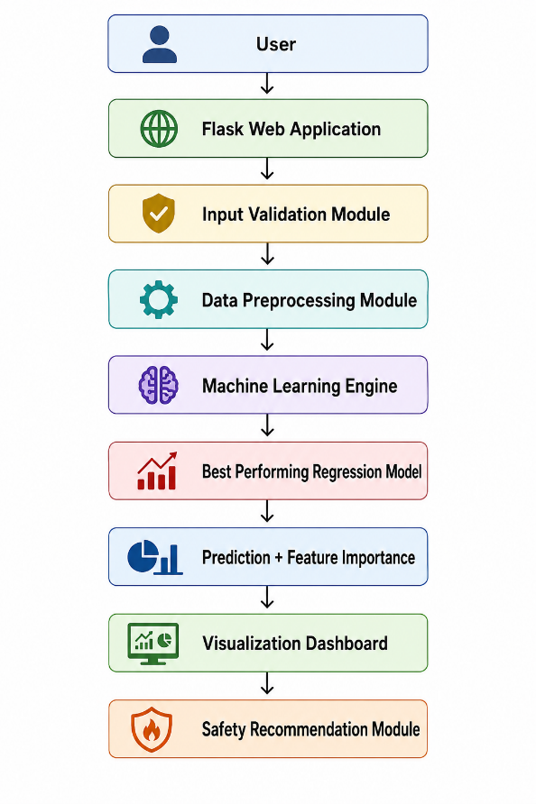

Technology Stack
Component | Technology
Programming Language | Python 3.x
Backend | Flask
Frontend | HTML5, CSS3, React
Machine Learning | Scikit-learn
Data Processing | Pandas, NumPy
Visualization | Plotly, Matplotlib
Model Explainability | SHAP / Feature Importance
Mapping | Folium / Leaflet.js
Report Generation | ReportLab
Model Storage | Joblib (.pkl)
Database (Optional) | PostgreSQL

Dataset
Dataset: UCI Forest Fires Dataset
Number of Records: 517
Features
Variable | Description
X | Spatial Coordinate
Y | Spatial Coordinate
Month | Month
Day | Day
FFMC | Fine Fuel Moisture Code
DMC | Duff Moisture Code
DC | Drought Code
ISI | Initial Spread Index
Temp | Temperature
RH | Relative Humidity
Wind | Wind Speed
Rain | Rainfall

Target Variable: Area
Measured in: Hectares

Machine Learning Workflow
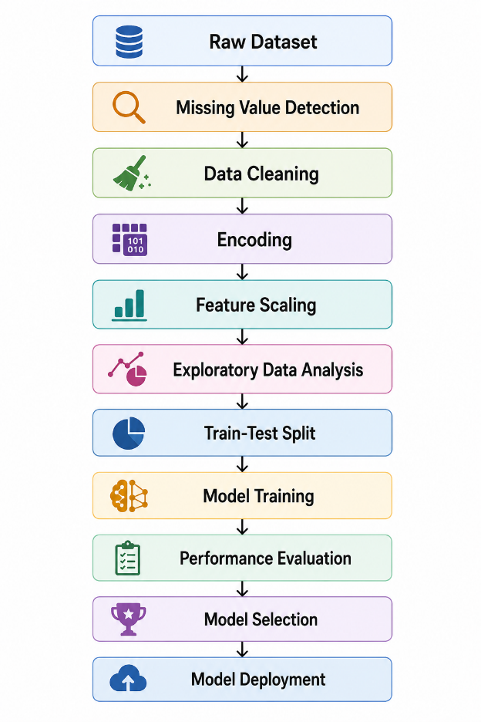

Data Preprocessing Dashboard
The application will contain a dedicated preprocessing dashboard allowing users to understand the quality of the dataset before model training.
Features
Dataset Summary
- Number of observations
- Number of variables
- Missing values
- Duplicate records
- Numerical features
- Categorical features

Data Cleaning Summary
Displays
- Missing values removed
- Duplicate rows removed
- Invalid records
- Outliers detected

Statistical Summary
Shows
- Mean
- Median
- Standard deviation
- Minimum
- Maximum

Correlation Matrix
Displays relationships between variables using a heatmap.
Purpose: Identify highly correlated meteorological variables.

Exploratory Data Analysis
The dashboard will provide multiple interactive visualizations.
Examples
- Burned area distribution
- Temperature distribution
- Humidity distribution
- Rainfall distribution
- Wind speed distribution
- Monthly fire frequency
- Seasonal fire trends

Machine Learning Models
The following regression models will be implemented.

Linear Regression
Purpose
Baseline model.
Advantages
- Simple
- Fast
- Easy to interpret

Random Forest Regressor
Purpose
Capture nonlinear relationships.
Advantages
- High accuracy
- Robust
- Feature importance

Gradient Boosting Regressor
Purpose
Improve prediction through sequential learning.
Advantages
- Handles complex patterns
- High predictive performance

Model Comparison Dashboard
After training, all models will be compared.
Model | MAE | RMSE | R² | Training Time
Linear Regression
Random Forest
Gradient Boosting

The best-performing model will automatically be selected for deployment.
Prediction Module
Users enter
- Temperature
- Relative Humidity
- Wind Speed
- Rainfall
- FFMC
- DMC
- DC
- ISI
- Month
- Day
- X Coordinate
- Y Coordinate
The trained model predicts: Estimated Burned Area: Hectares
Example: Predicted Burned Area - 18.43 hectares

Burn Severity Classification
The predicted burned area will be categorized into severity levels.
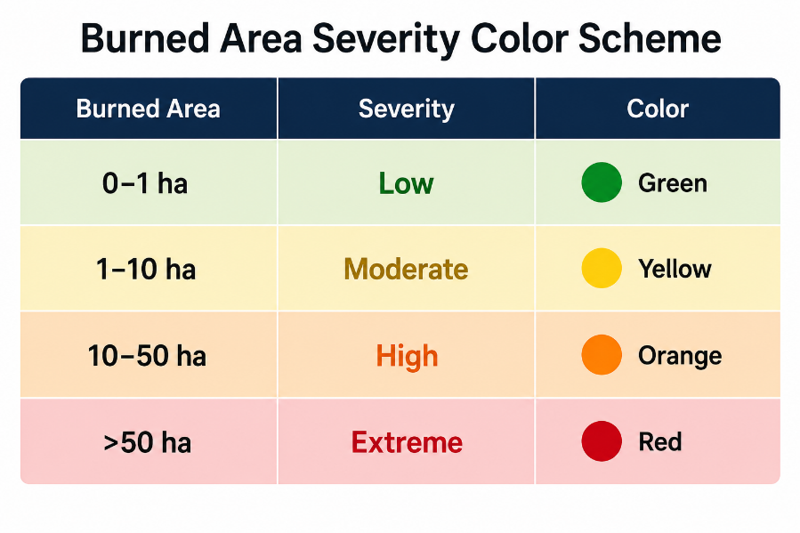
This classification enables quick interpretation by users.

Historical Fire Trend Analysis
Historical wildfire patterns will be visualized.
Charts include
- Monthly burned area
- Seasonal burned area
- Fire frequency
- Average temperature over time
- Rainfall trends
- Wind trends
Purpose
Understand historical wildfire behavior.

Interactive Charts
Interactive dashboards will be developed using Plotly.
Charts
- Line Charts
- Scatter Plots
- Histograms
- Box Plots
- Heatmaps
- Correlation Matrix
- Feature Importance
- Monthly Trends

Users can
- Zoom
- Hover
- Filter
- Download images

Feature Importance Visualization
The deployed model will explain which variables contributed most to the prediction.
Example

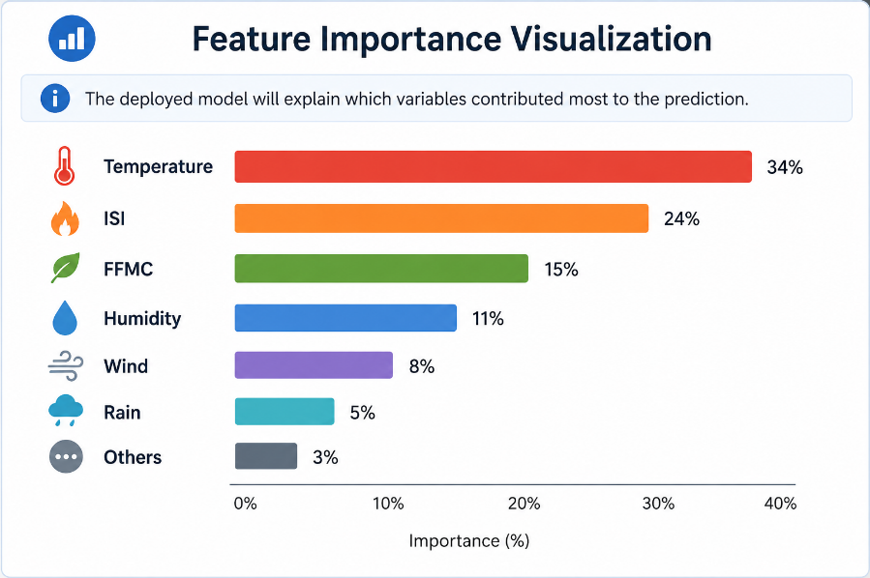

Prediction Explanation
Instead of displaying only the prediction, the system will explain why the result occurred.
Example
Prediction
18.43 hectares
Explanation
- High temperature increased fire intensity.
- Low humidity accelerated combustion.
- High ISI increased spread rate.
- Moderate wind supported fire expansion.

Map Visualization
If spatial coordinates are available, predictions will be displayed on an interactive map.
Map features
- Fire location marker
- Burn radius
- Severity color
- Burned area popup
- Zoom controls

Color scheme
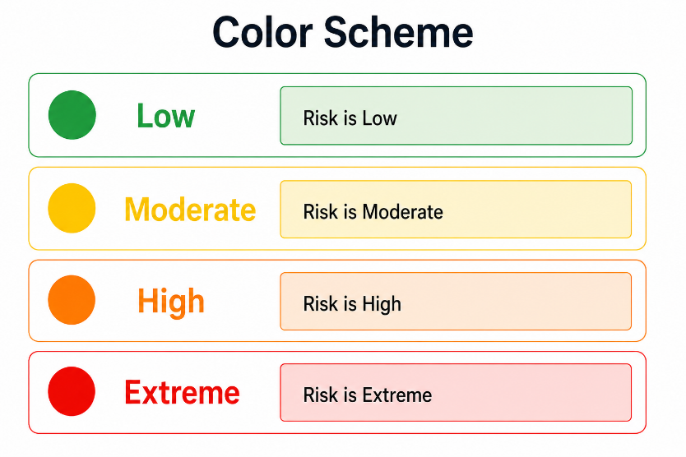
Technology
- Folium
- Leaflet.js

Safety Recommendation Module
Based on the predicted burn severity, the system will provide emergency guidance.
Low Risk
- Continue monitoring.
- Safe outdoor activities.
Moderate Risk
- Avoid open burning.
- Monitor local weather.
High Risk
- Prepare emergency resources.
- Restrict outdoor fire activities.

Extreme Risk
- Immediate evacuation planning.
- Notify emergency authorities.
- Avoid entering forest areas.

Downloadable PDF Report
Users may download a detailed prediction report.
The report includes
- Prediction ID
- Date and Time
- Meteorological inputs
- Predicted burned area
- Severity level
- Risk color
- Feature importance
- Safety guidance
- Map snapshot (optional)

Performance Evaluation
Models will be evaluated using
Mean Absolute Error (MAE): Measures average prediction error.
Root Mean Squared Error (RMSE): Measures prediction accuracy while penalizing large errors.
Coefficient of Determination (R²): Measures how well the model explains variability in burned area.

Expected Outputs
The final system will produce:
- Data preprocessing dashboard
- Dataset statistical summary
- Correlation analysis
- Historical wildfire visualizations
- Machine learning model comparison dashboard
- Burned area prediction in hectares
- Color-coded burn severity classification
- Feature importance visualization
- Interactive map of predicted burn location (when spatial coordinates are available)
- Safety recommendations based on risk level
- Downloadable PDF prediction report

